SEMESTER TWO
Papers written by
Australian Maths Software

YEAR 12

MATHEMATICS SPECIALIST

UNIT 3-4

REVISION TWO

2016
Section One
(Calculator–free)

Name: _________________________________

Teacher: ________________________________

TIME ALLOWED FOR THIS SECTION

Reading time before commencing work: 5 minutes
Working time for section: 50 minutes

MATERIAL REQUIRED / RECOMMENDED FOR THIS SECTION

To be provided by the candidate
Standard items: pens, pencils, pencil sharpener, highlighter, eraser, ruler.
Special items: nil.

IMPORTANT NOTE TO CANDIDATES
No other items may be taken into the examination room. It is your responsibility to ensure that you do not have any unauthorised notes or other items of a non–personal nature in the examination room. If you have any unauthorised material with you, hand it to the supervisor before reading any further.

To be provided by the supervisor
Question/answer booklet for Section One.
A formula sheet which may also be used for Section Two.
Structure of this examination

 | Number of questions available | Number of questions to be answered | Working time (minutes) | Marks available | Percentage of exam
Section One  Calculator—free | 8 | 8 | 50 | 52 | 35
Section Two  Calculator—assumed | 12 | 12 | 100 | 98 | 65
Total marks |  |  |  | 150 | 100

Instructions to candidates

1. The rules for the conduct of this examination are detailed in the Information Handbook.
Sitting this examination implies that you agree to abide by these rules.

2. Write your answer in the Question/Answer booklet.

3. You must be careful to confine your responses to the specific questions asked and to
follow any instructions that are specific to a particular question.

4. Spare pages are provided at the end of this booklet. If you need to use them, indicate
in the original answer space where the answer is continued i.e. give the page number.

5. Show all your working clearly. Your working should be in sufficient detail to allow your
answers to be checked readily and for marks to be awarded for reasoning. Incorrect
answers given without supporting reasoning cannot be allocated any marks. For any
question or part question worth more than two marks, valid working or justification is
required to receive full marks. If you repeat an answer to any question, ensure that you
cancel the answer you do not wish to have marked.

6. It is recommended that you do not use pencil, except in diagrams.

7. The Formula Sheet is not to be handed in with your Question/Answer booklet.

1. (6 marks)

(a) If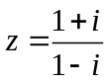 find
(i) 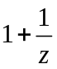 (2)

(ii) 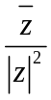 (2)

(b) Define the shaded region graphed on the set of axes below. (2)

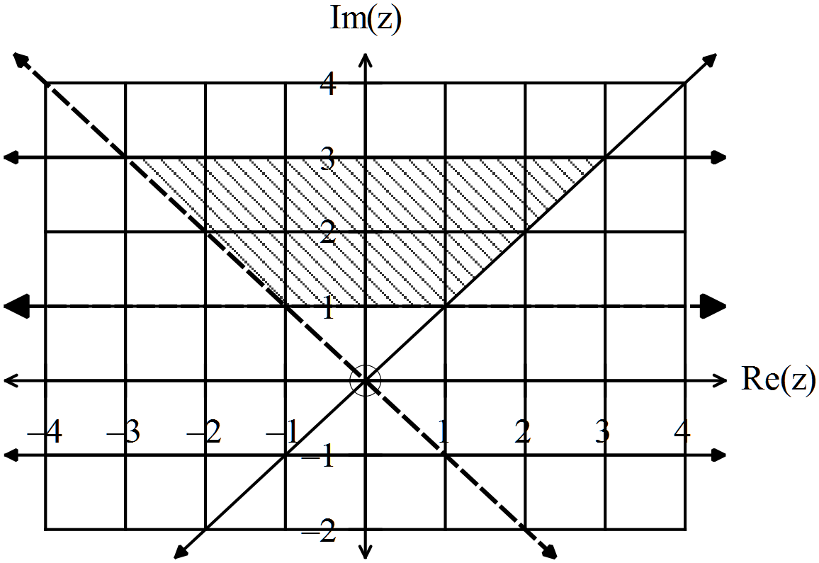

2. (6 marks)
(a) Find the expression for 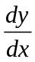given the relationship 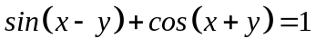
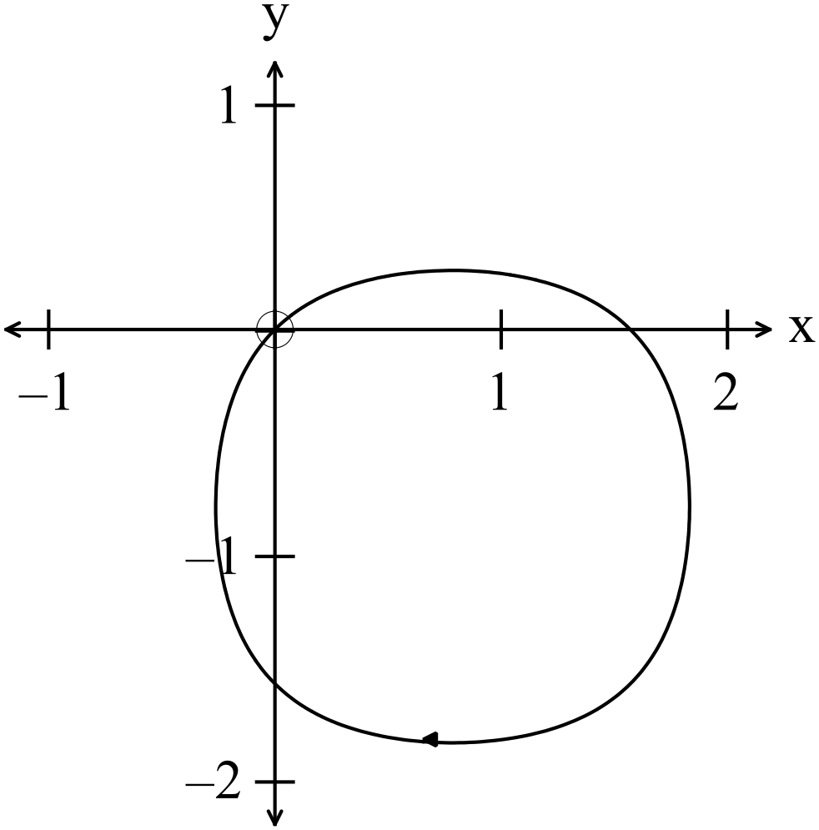 (4)

(b) Hence find at the point 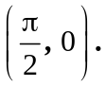 (2)

3. (10 marks)
(a) Determine (3)

(b) Determine 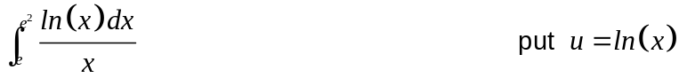 (3)

(c) Evaluate (4)

4. (3 marks)

Two of the six roots of an equation are sketched below.
Find the equation and the other roots. (3)

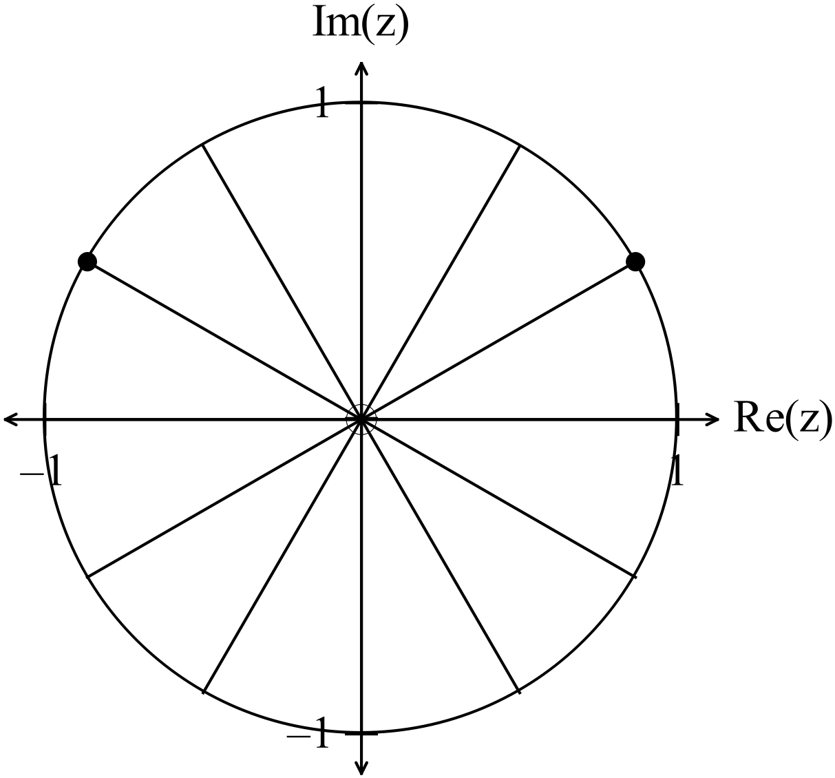

5. (6 marks)
(a) Prove that the equations have two common roots. Determine the common roots. (4)

(b) Determine the equation that has the roots 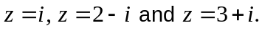. (2)

6. (6 marks)
(a) The function 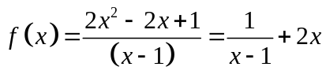.
Consider the limit of the function as 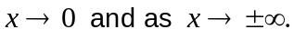
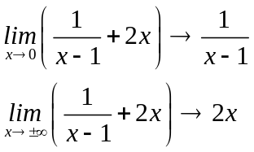

Use these limits to sketch the graph of the function 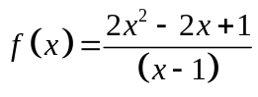. (4)

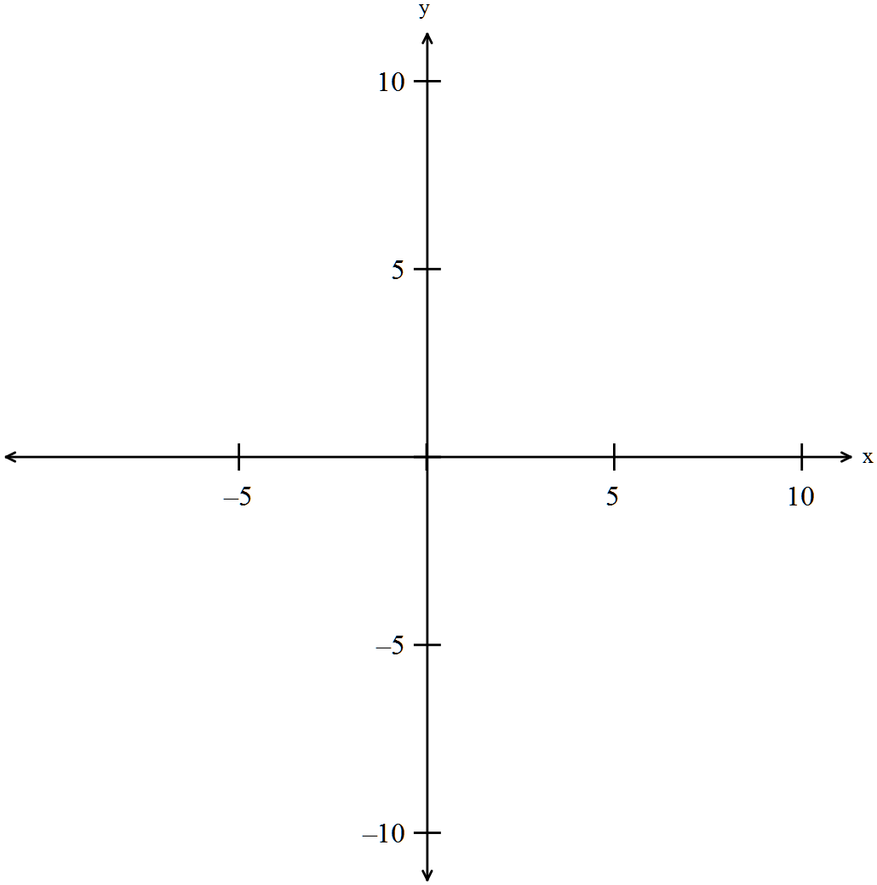

(b) The function 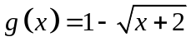 is sketched on the set of axes below.
Sketch 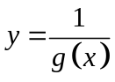 on the set of axes below. (2)

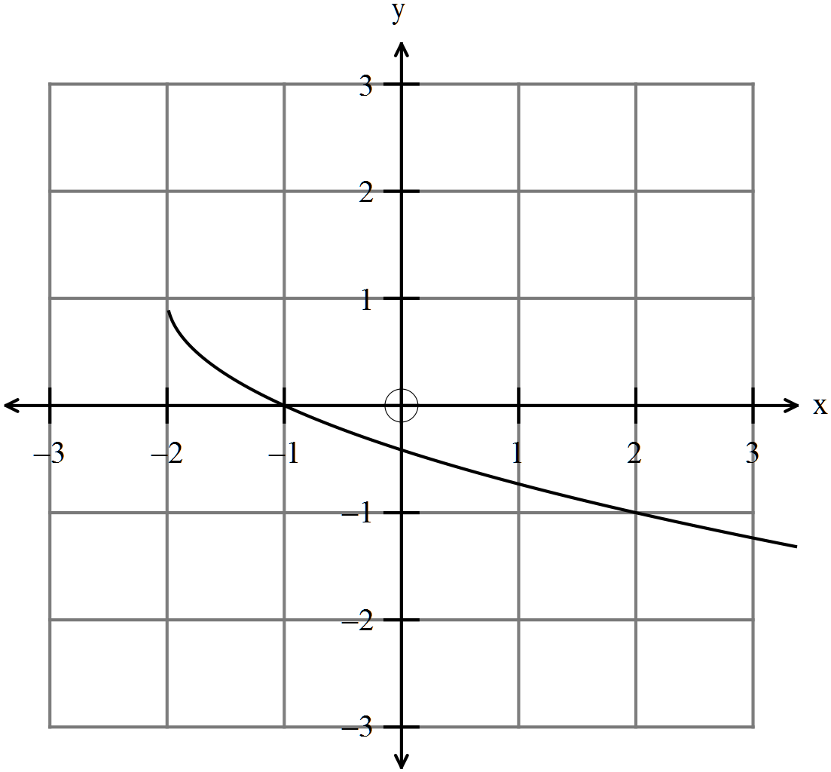

7. (11 marks)

The position vector of a particle travelling in an ellipse as shown on the graph
below is given by 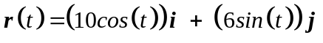for any time .
Measurements are in metres and time in seconds.

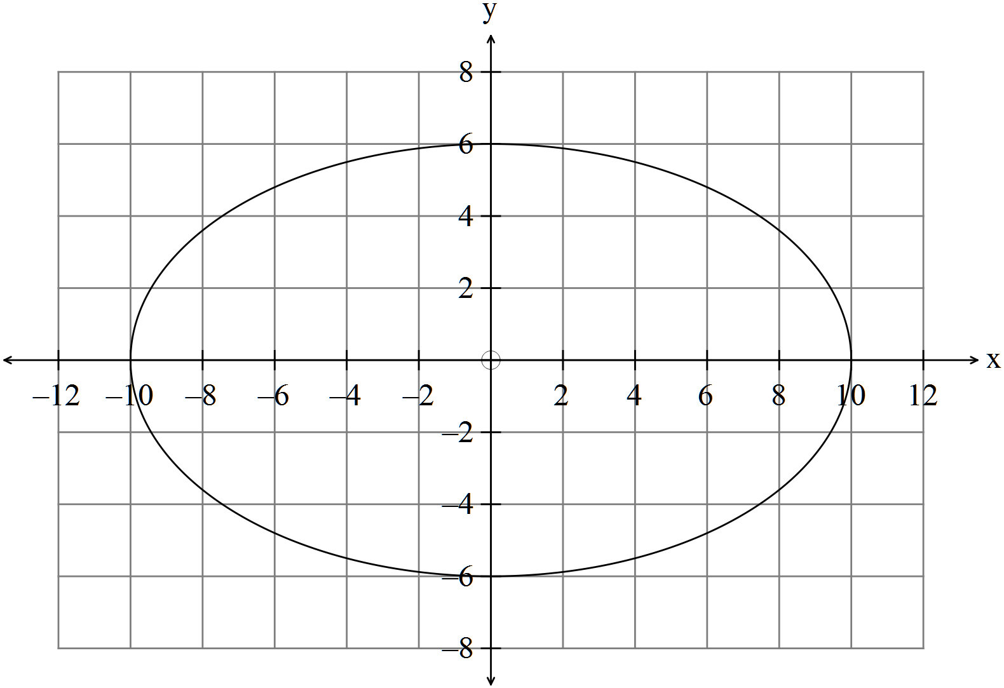
(a) Find an expression for the speed of the particle. (2)

(b) Use the expression found in (i) to determine the maximum and minimum
speeds of the particle. (2)

(c) Determine where on the particle the maximum and minimum speeds occur.
(2)

(d) Find the acceleration at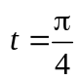 and sketch the acceleration vector on the
diagram at . (3)

(e) Find the Cartesian equation of the path of the particle. (2)
8 (4 marks)

Determine 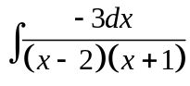
HINT: Use partial fractions. (4)

END OF SECTION ONE

